CULTURAL IMPERIALISM

1. Imperialism and westernization
2. Popular imperialism in Britain (Text and Documents)
3. Images of Imperialism (Cartoons and Advertisements)
The Age of Empire was not only an economic and political but also a cultural phenomenon. The conquest of the globe by a 'developed' minority transformed images, ideas and aspirations both at home, in Britain, and throughout the dependent Empire and the Dominions.
1. Imperialism and westernization
In the dependent countries, westernization hardly touched anyone except the indigenous elites, those who had direct contact with the occupiers: but imperialism, its mechanisms and the Christian missions, by educating these elites in the western manner created the conditions for new social and political elites to develop, ironically often those who then led the struggle for independence in their country.
Indeed the great mass of the colonial populations hardly changed their way of life at all, though many had no choice. And even when they were in contact with the religion, the ideas and ideals imported from the west, they did not necessarily adopt them totally, but rather just took only those elements which made sense to them as they fitted in with, or could be adapted to, their own existing system of beliefs and institutions.
Imperialism brought ‘westernization’ to the elites of the dependent world and even this elite’s eventual resistance to the west remained a westernizing process though it often attacked that same westernization for reasons of religion, morality, ideology or simply for political pragmatism. For example, Mahatma Gandhi, a Hindu, was a western-educated lawyer and both western-derived ideology and his own social and cultural origins influenced his strategies when organising resistance to Britain.
The Age of Empire created both the conditions which formed anti-imperialist leaders and the conditions in which their voices could be heard. But the history of the peoples and regions brought under the domination and influence of the western powers should not be told primarily in terms of resistance to the west. Indeed, with rare exceptions, the era of anti-imperial movements began during or after WWI and were led by newly westernized elites who had come into contact with such ideas when visiting, being educated, or fighting, as many colonial troops did, in the Great War in Europe.
a) Decide whether the following statements are true or false and explain why
1. The cultural imperialism of western countries affected only a minority of educated indigenous people
______________________________________________________________________________
______________________________________________________________________________
______________________________________________________________________________

2. Indigenous people who converted to western religions often developed their own versions of the faith.
_____________________________________________________________________________
_____________________________________________________________________________
_____________________________________________________________________________

3. ‘Westernization’ was a new cultural phenomenon which worked to preserve the Empire. ____________________________________________________________________________
____________________________________________________________________________
____________________________________________________________________________
4. Gandhi strongly opposed westernization. ____________________________________________________________________________
____________________________________________________________________________
____________________________________________________________________________
5. The Age of Imperialism created the conditions for its eventual collapse. ____________________________________________________________________________
____________________________________________________________________________
____________________________________________________________________________
6. There was widespread resistance to Imperialism among the occupied peoples before 1914. ____________________________________________________________________________
____________________________________________________________________________
____________________________________________________________________________
2. Answer the following questions:
- What does ‘education in a western manner’ mean? Give some examples
- Try to define the term ‘westernization’ in your own words. What do you think is the difference between westernization and globalization’? Give examples.
- Try to describe and explain the relationship between the ‘westernized elites’ in the countries of the Empire and the ‘anti-imperialism’ these same elites developed. Why were they so often leaders in independence movements?
2. Popular imperialism in Britain
1) Before reading find out what the term popular culture means and, with the rest of the class, decide: - what its main features are - who it affects - who it involves - how it is transmitted - why it is transmitted and by whom? - Is it the same as culture?

Towards the end of the nineteenth century there was increased enthusiasm for Empire among the ordinary people of Britain which MacKenzie, (1984, 1986) called popular imperialism. Various institutional and cultural forces helped to develop and promote a new vision of Empire among the general public. “Promotion” started in the schools, where British school children were encouraged to feel proud of being part of a nation which ruled the world's largest empire ever, one on which 'the sun never sets'. Hymns, written to be sung not only in Church but also at Sunday School and in school assemblies, often included at least implicit references to Empire. One of the most beautiful of all simple Victorian tunes was written to accompany 'The Day Thou Gavest, Lord, is ended'. An important part of that hymn's message was that, while the sun might be setting on the heart of the Empire (Britain), it was rising elsewhere. National pride, national loyalty but also the association between nation and race patriotism based on ethnic identity (Doc. 1-2 below) became important contents of the curriculum for children of the upper, middle and working classes.
Popular literature too, did much to influence and reinforce public attitudes. Towards the end of the century the imperial romances of Rudyard Kipling, H. Rider Haggard and Robert Louis Stevenson were very widely read. Kipling was recognised as the bard of Empire, especially with his poems 'Recessional' (1897) and 'The White Man's Burden' (1898), which portrayed imperialism as a noble, civilising endeavour. Kipling also realised it was important to inculcate the imperial spirit from early on and he produced equally popular literature for children too, for example the Just - So Stories and The Jungle Book.
Popular imperialism extended to activities and organisations that instilled discipline and a sense of duty in youth. There was the Boys' Brigade (1883), teetotal (alcohol was seen as a major problem in Victorian society) and with military overtones: it was set up to keep boys off the streets. The Boy Scouts (1907) were founded by Lord Robert Baden- Powell, who “drew directly on his own imperial experiences (especially during the Boer War) in shaping the group's ethos, activities and uniform” (Rosenthal, 1986; Springhall, 1977). These youth groups were just one of the ways imperialism and militarism came to influence late-Victorian popular imagination.
One of the best known and most influential evangelical organisations was the Salvation Army, which made many converts with its uniforms, bands and marches, its agricultural 'colonies', and the help it offered to migrants within the empire and to the poor at home. The Empire was publicised and commercialised as never before for domestic consumption: international fairs and exhibitions would usually include model villages where Africans and other 'exotic' peoples “lived”, to show, create an image of the Empire, of the need for “civilisation”. Museum curators prepared ethnographic exhibitions of objects from conquered peoples, even religious artefacts became “Art” and lost their true significance, nonetheless they inspired many European artists of the time. In the theatre, the dramas and emotions of imperial conquest were recreated for the entertainment and edification of audiences; while the Music Halls (variety theatres) packed their auditoriums and halls by offering programmes with imperial themes. The more extreme public expressions of patriotism even got their own term: 'Jingoism' (Doc 3 below).
2. Underline all the information in the text that could be useful to explain:
A. why popular imperialism spread
- what values and ideals it spread and reinforced
- who it was mainly aimed at, what type of people
D. with no radio or TV available, how was it transmitted
3. Read documents 1 and 2 below and underline expressions, evidence, referring to the attitudes and beliefs that were spread through popular imperialism and check your answers with the rest of the class
DOCUMENT 1: IMPERIALISM AS RACIAL DESTINY
In 1877 Cecil Rhodes, who had just begun to make his fortune in the Kimberley diamond fields of South Africa, drafted a 'confession of faith' that expressed his messianic imperial vision, which held that it was right and proper for the 'Anglo-Saxon race' to expand at the expense of inferior peoples.
I contend that we are the finest race in the world and that the more of the world we inhabit the better it is for the human race. Just fancy those parts that are at present inhabited by the most despicable specimens of human beings what an alternation there would be if they were brought under Anglo-Saxon influence, look again at the extra employment a new country added to our dominions gives ... I contend that every acre added to our territory means in the future birth to some more of the English race who otherwise would not be brought into existence. . .. Africa is still lying ready for us it is our duty to take it. It is our duty to seize every opportunity of acquiring more territory and we should keep this one idea steadily before our eyes that more territory simply means more of the Anglo-Saxon race more of the best the most human, most honorable race the world possesses.
Cecil Rhodes, 'Confession of Faith', 1877.
DOCUMENT 2: SOCIAL DARWINISM
Social Darwinism applied Darwin’s Law of Natural Selection to human society. Darwin’s law had been elaborated to explain the evolution of animals and, when applied to human society, it was turned into not only an ideological justification and explanation of political and economic competition between nations but also of the natural superiority of one race over another. The late-Victorian social theorist Benjamin Kidd was just one who sought to explain the expansion of the 'Anglo-Saxon' across the globe in terms of Darwinian theory, he argued that it was a natural law of progress that overrode humanitarian concerns for the fate of 'weaker races'.
We watch the Anglo-Saxon overflowing his boundaries, going forth to take possession of new territories, and establishing himself like his ancestors in many lands. A peculiar interest attaches to the sight. He has been deeply affected, more deeply than many others, by the altruistic influences of the ethical system upon which our Western Civilisation is founded. He had seen races like the ancient Peruvians, the Aztecs, and the Caribs (1), in large part exterminated by others, ruthlessly driven out of existence by the more vigorous invader, and he has at least the wish to do better. . . . Yet neither wish nor intention has power apparently to arrest a destiny which works itself out irresistibly. The Anglo-Saxon has exterminated the less developed peoples with which he has come into competition even more effectively than other races have done in like case; not necessarily indeed by fierce and cruel wars of extermination, but through the operation of laws not less deadly and even more certain in their result. The weaker races disappear before the stronger through the effects of mere contact... No motives appear to be able to stay the progress of such movements, humanize them how we may. We often in a self-accusing spirit attribute the gradual disappearance of aboriginal peoples to the effects of our vices upon them; but the truth is that what may be called the virtues of our civilisation are scarcely less fatal than its vices . . . . Wherever a superior race comes into close contact and competition with an inferior race, the result seems to be much the same, whether it is arrived at by the rude method of wars of conquest, or by the silent process which we see at work in Australia, New Zealand, and the North American Continent. . . .
- Caribs: now extinct tribes of the Caribbean area.
Benjamin Kidd, Social Evolution, (New York: Macmillan, 1894), pp. 45-8
4) Read document 3, an extract from the Encyclopedia Britannica, and answer the questions as you find them in the text below

DOCUMENT 3: Encyclopedia Britannica 1911
A) Why does the author feel the word empire should be re-defined?
B) Whose point of view is considered?
C) What type of market is developing?
D) Which sector is going to benefit in particular?
E) Is he saying that increased movement of populations will make “race difference” more or less marked?
F) As you read on, underline the categories he uses to classify the human race and note the “emotional” value-laden words used.
BRITISH EMPIRE, the name now loosely given to the whole aggregate of territory, the inhabitants of which, under various forms of government, ultimately look to the British crown as the supreme head. The term "empire" is in this connection obviously used rather for convenience than in any sense equivalent to that of the older or despotic empires of history. (A)
The land surface of the earth is estimated to extend over about 52,500,000 sq. m. Of this area the British Empire occupies nearly one-quarter, extending over an area of about 12,000,000 sq. m. By far the greater portion lies within the temperate zones, and is suitable for white settlement. (B)
The area of the territory of the empire is divided almost equally between the southern and the northern hemispheres, [...] the southern hemisphere [covers] 5,308,506 sq. m., while [...] the northern hemisphere [covers] 5,271,375 sq. m. The alternation of the seasons is thus complete, one-half of the empire enjoying summer, while one-half is in winter. [...] one-half enjoying daylight, while the other half is in darkness. These alternations of time and of seasons [....are thought] to have an increasingly important effect upon the material and industrial, as well as upon the social and political developments of the empire. This will become evident in considering the industrial productions of the different divisions, and the harvest seasons which permit the summer produce of one portion of the empire to supply the winter requirements of its other markets, and conversely. (C & D)
The effect of climate throughout the empire in modifying the type of the Anglo-Saxon race has as yet received only partial attention, and conclusions regarding it are of a somewhat empiric nature*. The general tendency in Canada is held to be towards somewhat smaller size, and a hardy active habit; in Australia to a tall, slight, pale development locally known as "cornstalkers," characterised by considerable nervous and intellectual activity. In New Zealand the type preserves almost exactly the characteristics of the British Isles. The South African, both Dutch and British, is readily recognised by an apparently sun-dried, lank and hard habit of body.
It is to be observed in reference to this interesting aspect of imperial development, that the multiplication and cheapening of channels of communication and means of travel throughout the empire will tend to modify the future accentuation of race difference, while the variety of elements in the vast area occupied should have an important, though as yet not scientifically traced, effect upon the British imperial type. (E) (F)
The white population of the empire reached in 1901 a total of over 53,000,000, or something over one-eighth of its entire population. Population, which, including native races, is estimated at about 400,000,000. The white population includes some French, Dutch and Spanish peoples, but is mainly of Anglo-Saxon race.
The native population of the empire includes types of the principal black, yellow and brown races, classing with these the high-type races of the East, which may almost be called white. The native population of India, mainly high type, brown, was returned at the census of 1901 as 294,191,379. The aboriginal races of South Africa [...] are rapidly diminishing in numbers, and in British South Africa it is expected that they will in the course of the twentieth century become extinct. Besides these primitive races there are the dark-skinned negroids of Bantu stock [...] From east to west across Africa the aboriginal nations are mostly of the black negroid type. The tendency of some of the lower negroid types has been to drift towards the west coast, where they still practice cannibalistic and fetish rites. On the east coast are found much higher types approaching to the Christian races of Abyssinia, and from east to west there has been a wide admixture of Arab blood producing a light-brown type. In Uganda and Nigeria a large proportion of the population is Arab and relatively light-skinned.
The native races of Australia and the Polynesian groups of islands are divided into two main types known as the dark and light Polynesian. The dark type, which is black, is of a very low order, and in some of the islands still retains its cannibal habits. The aboriginal tribes of Australia are of a low-class black race, but generally peaceful and inoffensive in their habits. The white Polynesian races are of a very superior type, and exhibit, as in the Maoris of New Zealand, characteristics of a high order. The natives of Papua (New Guinea) are in a very low state of civilisation. Numbers are approximate, as no census has been taken. The population of the empire may be calculated as amounting to something more than one-fourth of the population of the world.
Source Gutenberg Project: http://www.gutenberg.org/etext/19699
What values did the imperialists think were important? What theories seem to be accepted as “fact” i.e. are not challenged?
DOCUMENT 4: JINGOISM
The term 'jingoism' entered the vocabulary of political debate in the late nineteenth century to describe popular enthusiasm for colonial wars and other aggressive assertions of national power. Liberal critics, like J. A. Hobson, believed the music halls and the press manipulated the patriotic emotions of the public and corrupted the democratic process.
The quick ebullition (bubbling or boiling over) of national hate termed Jingoism is a particular form of this primitive passion, modified and intensified by certain conditions of modern civilisation. . . Among large sections of the middle and labouring classes, the music- hall, and the recreative public-house into which it shades off by imperceptible degrees, are a more potent educator than the church, the school, the political meeting, or even than the press. Into this 'lighter self' of the city populace the artiste conveys by song and recitation crude notions upon morals and politics, appealing by coarse humour or exaggerated pathos to the animal lusts of an audience stimulated by alcohol into appreciative hilarity. In ordinary times politics plays no important part in these feasts of sensationalism, but the glorification of brute force and an ignorant contempt for foreigners are ever-present factors which at great political crises make the music-hall a very serviceable engine for generating military passion.
J. A. Hobson, The Psychology of Jingoism (London: Grant Richards, 1901), pp. 2-3.
a. Explain Jingoism in your own words. ______________________________________________________________________________
______________________________________________________________________________
______________________________________________________________________________
b. How did Hobson define Jingoism? ______________________________________________________________________________
______________________________________________________________________________
______________________________________________________________________________
c. Find the ways mentioned in the text by which the ideas of popular imperialism are propagated, spread and reinforced. _____________________________________________________________________________
_____________________________________________________________________________
_____________________________________________________________________________
d. Why does Hobson say that music halls and public houses are “more potent educators than the church, the school, the political meeting or even the press”? _____________________________________________________________________________
_____________________________________________________________________________
_____________________________________________________________________________
DOCUMENT 5: The White Man’s Burden
3) Read the text, then complete the tasks below
Joseph Rudyard Kipling (1865 - 1936), perhaps best known today for his novel “The Jungle Book”, was a British author and poet, born in British India, but sent to school in England, like many colonists’ children were. In 1882, he returned to India where he worked as a journalist and began publishing poems and stories. He was a prolific writer and for a time very popular. He was awarded the Nobel Prize for Literature in 1907 and is still the youngest person ever to have won it.
Kipling was a master in his use of language he could convey the feelings and emotions of both the British ruling classes, the common soldiers and the natives. He has often been accused of jingoism, of being the voice of imperialism, and of being overly sentimental about colonialism, however much of his writing does suggest that he genuinely believed in the positive role the introduction of Western ideas could play in improving the lives of non-Western peoples. Who knows, it depends on the point of view of the critic. His nationalism, however, was not entirely uncritical: The Old Issue (1900) was strongly critical of the Boer War and the danger of unlimited and despotic power, and his Recessional: a Victorian Ode (1897), could be read as a warning to Britain that this Empire, like all other empires before it, will end.
In 1899, after he had returned to England to live, he published "The White Man's Burden" in a popular US magazine called McClure's. He wrote it partly to help sway (influence) popular opinion in the US and get people to accept their country occupying the Philippines (1899). The poem opens with a declamatory command: “Take up the White Man's burden” and every verse starts with the same words, like a refrain. The poem praises the spirit of self-sacrifice among colonists and the colonising powers that “send their best” young people to “exile” in the colonies in order to serve the native people. In lines 3 - 5 of the first verse (below) Kipling even seems to suggest that it is not just the native people who are enslaved, but the functionaries of empire too as they feel equally caught up, frustrated and powerless while in Colonial service.
This is the first verse of the poem:

Take up the White Man's burden –
Send forth the best ye (1), breed—
Go bind your sons to exile
To serve your captives' need;
To wait (2), in heavy harness (3),
On fluttered (4) folk and wild--
Your new-caught, sullen (5) peoples,
Half-devil and half-child.
Kipling recognises that the colonists’ task was not easy and they often failed because of the natives’ lack of co-operation, as he tells them in verse 3 (ll.21-24):

“And when your goal is nearest
The end for others sought,
Watch sloth (6) and heathen folly
Bring all your hopes to nought (7)”
In other words: the colonised people did not always co-operate with the colonists and either out of laziness or by directly opposing them stopped the occupiers from always doing whatever they wanted. Kipling also later refers to the ungratefulness of the natives who resent the efforts of the Colonists to help them and would prefer to remain “uncivilized” and they cry out accusingly against the colonist “Why brought he us from bondage / our loved Egyptian night?” (ll. 39, 40).

(1) ye = you;
(2) to wait ... on = to serve;
(3) in heavy harness = doing difficult tasks;
(4) to flutter = to make short quick light movements, associated often with an idea of inconstancy, unreliability, irresponsibility;
(5) sullen peoples = uncooperative attitudes and behaviour;
(6) sloth: laziness = idleness;
(7) come to nought = come to nothing, fail
a) Re-read the first verse and underline the words Kipling uses to describe the colonised people.
b) What impression, what image, does Kipling give of the average colonist? Describe him / her choosing adjectives from the list below. _____________________________________________________________________________
_____________________________________________________________________________
_____________________________________________________________________________
_____________________________________________________________________________
_____________________________________________________________________________
_____________________________________________________________________________
generous – brave - irresponsible – powerless - cruel - self-sacrificing – greedy – steadfast – humble – selfish - wanting to serve – patient – intolerant – tolerant – dutiful – unselfish – frustrated

c) How would you describe Kipling’s attitude to Empire and Imperialism? Was he for or against imperial expansion? Did he see it as beneficial for the occupied peoples? Decide what you think and discuss your answers with the rest of the class.
_____________________________________________________________________________
_____________________________________________________________________________
____________________________________________________________________________
____________________________________________________________________________
____________________________________________________________________________
____________________________________________________________________________
____________________________________________________________________________
____________________________________________________________________________
____________________________________________________________________________
____________________________________________________________________________
____________________________________________________________________________
____________________________________________________________________________
____________________________________________________________________________
____________________________________________________________________________
____________________________________________________________________________
____________________________________________________________________________

3. Images of Imperialism
1) Before reading make sure you know what the following terms mean, use your dictionary if necessary:
a) catchword – _________________________________________________________
b) association of ideas – __________________________________________________
c) set of beliefs – _______________________________________________________
d) symbol – ___________________________________________________________
Images/catchwords which would be recognised by a large section of a population are very important for understanding the society that produced them as they reveal how the general public was thinking, or being encouraged to think, at the time. This is not only true of social and political cartoons, whose function was/is explicitly to transmit a message and comment on events or situations, but also to what was a fairly new area within graphic art which also tried to communicate as well as possible: advertising, for adverts too use words and symbols to amplify the force of their message.
Both cartoons and adverts try to trigger, to set off, the chain of associations that people automatically make when they see the message (word / image / symbol). These almost automatic reflex associations are culturally determined, that is, they are influenced by
the individual’s previous knowledge and experience and by his/her social and economic position, politics, beliefs... The meaning of a symbol often changes over time, as societies’ values change, so the message in these two types of image can give historians a good insight into what the majority of the population thought, accepted as fact, believed at any one time. Sometimes, through frequent use, a symbol may even become permanently associated with a person, a country or a concept.
CARTOON 1 - Caption: The Rhodes Colossus: Spanning Africa from Cape to Cairo
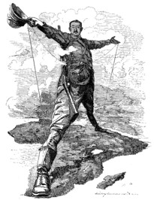
The Rhodes Colossus is an iconic (very famous, well and widely recognised) cartoon about the Scramble for Africa. The person shown is British colonist, Cecil Rhodes (who gave his name to Northern and Southern Rhodesia). The cartoon was drawn by Edward Linley Sambourne and first appeared in 1892, in Punch, a British weekly satirical magazine.
1) In pairs or small groups answer the following question (make notes). Then discuss your ideas with the rest of the class and decide. What do you remember about Rhodes and his ideas? And about the Scramble for Africa?
What was the original Colossus of Rhodes? What was it for? Explain the caption
2) Describe the image
a) Describe Rhodes, his position, his attitude, how he’s feeling, what he’s wearing
- Where is he standing?
- How is he standing?
- Why do you think he is standing like this?
- What impression does he give you? Confidence? Power ..... or what?
Comment on the perspective from which the figure has been drawn.
- What dominates in the foreground? Closest to the viewer?
- What do you associate with this image?
- Why is this first image important?
- Does it affect how viewers look at Rhodes? Does it force them to look at him at him from a single viewpoint? Is this important? Why/why not ?
3) The next closest dominant object is a solar topee, a special hat widely used by European colonists when in India and Africa to protect their heads from the sun (topi means hat in Hindi).
  - What do you think does the cartoonist want the viewer to think about, to associate that hat with?
  - What else is Rhodes holding in his hands? What is its significance (think about what the Victorian schoolgirl wrote)?
  - Is there anything else in the image you think is important to understand the message the cartoonist wants to give?
4) What is the message of this cartoon? What have you and your partner understood?
5) In your opinion the cartoonist pro or anti imperialism?

CARTOON 2 - The Occupation of Egypt (1882)
CAPTION: “Civiltà, Umanità, Libertà, Nazionalità, Fraternità (1) ... Taratatà... John Bull (2), with all due respect to Europe (3), speaks up in favour of Egyptian civilization”
(1) translation: Civilization, Humanity, Liberty, Nationality, Fraternity ...
(2) John Bull - had long stood for the typical “True Englishman”, a yeoman farmer image. In 19th century satirical cartoons John Bull was still the (stereo) typical Englishman, but was now more the imperialist British bourgeoisie, the privateers, traders, explorers, administrators and soldiers who were building and extending the Empire.
(3) with all due respect to Europe – means (here): in spite of Europe’s opinion

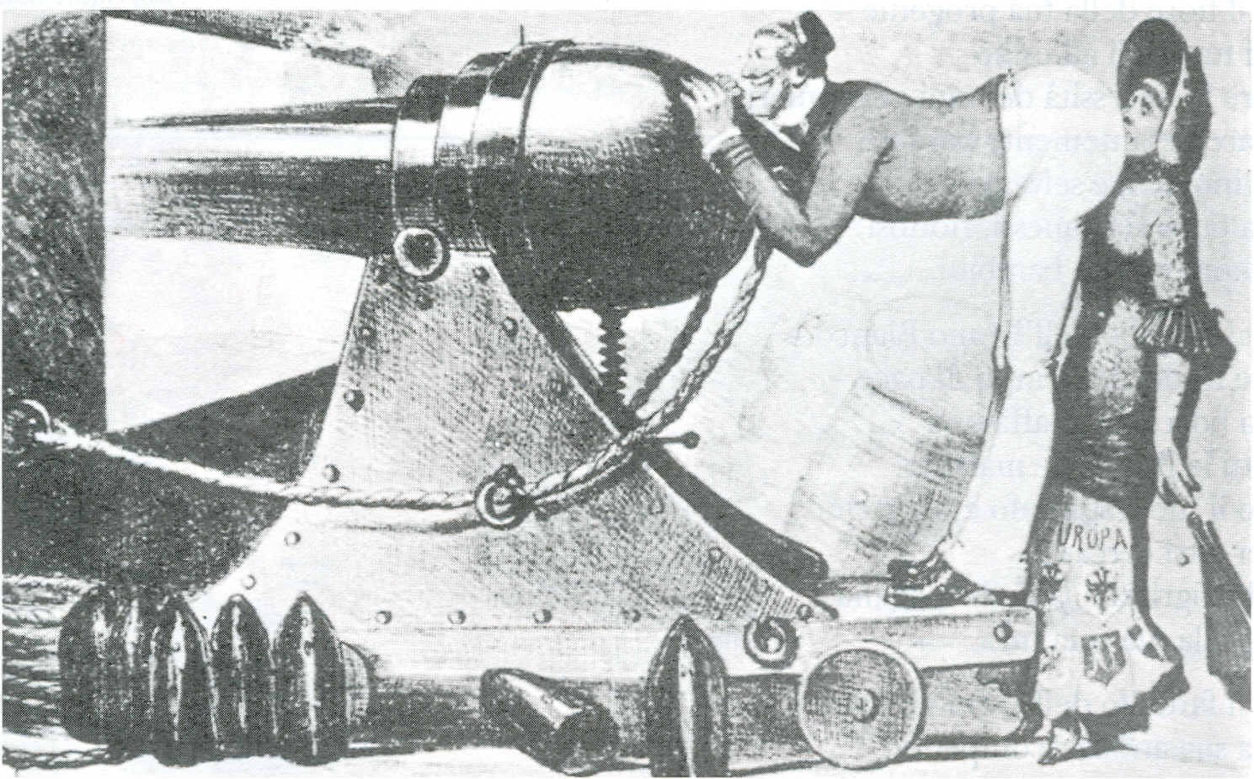

In this cartoon an Italian cartoonist, Casimiro Teya (1830-1897), offers his view of the British occupation of Egypt. This cartoon appeared on 18th July 1882 in “Il Pasquino”, an Italian satirical magazine which was first published in Turin, in 1856.
a) Set the scene: before analysing the cartoon: find out about the British Occupation of Egypt and Europe’s reaction to it. Pool your information in class and describe / discuss the situation in Egypt at the time. Use the Scramble for Africa timeline too.

b) Analyse the cartoon with a partner by completing the chart below.
Are there any words/text in the cartoon? Where? | __________________________________________________________
Describe the people portrayed | MAN | WOMAN
How are they dressed?  How are they feeling? (describe their position, facial expression)  Who or what do you think they represent?  What are they doing?  Can you identify them by name?  Are they realistic?  Are they stereotypes?  What sort of relationship do they seem to have? | ____________________________  ____________________________  ____________________________  ____________________________  ____________________________  ____________________________  ____________________________  ____________________________  ____________________________  ____________________________  ____________________________  ____________________________  ____________________________  ____________________________  ____________________________  ____________________________  ____________________________  ____________________________ | ___________________________  ___________________________  ___________________________  ___________________________  ___________________________  ___________________________  ___________________________  ___________________________  ___________________________  ___________________________  ___________________________  ___________________________  ___________________________  ___________________________  ___________________________  ___________________________  ___________________________  ___________________________
Where is the action set (taking place)?  Describe the objects in the cartoon. Start with the one that seems to dominate the scene, by size or visual impact - it is probably the most important, then the next most important etc. | __________________________________________________________  __________________________________________________________  __________________________________________________________  __________________________________________________________  __________________________________________________________  __________________________________________________________  __________________________________________________________  __________________________________________________________  __________________________________________________________  __________________________________________________________  __________________________________________________________  __________________________________________________________
Do these objects have any symbolic meanings for you? If so, what do you associate them with?  Look at the title: what is the Cartoonist saying re- write it in your own words.  Which particular aspect(s) of cultural imperialism is the cartoonist commenting on/criticising, or both?  Summarise the message you think the cartoonist wanted to give the reader. | __________________________________________________________  __________________________________________________________  __________________________________________________________  __________________________________________________________  __________________________________________________________  __________________________________________________________  __________________________________________________________  __________________________________________________________  __________________________________________________________  __________________________________________________________  __________________________________________________________  __________________________________________________________  __________________________________________________________  __________________________________________________________  __________________________________________________________  __________________________________________________________  __________________________________________________________  __________________________________________________________  __________________________________________________________  __________________________________________________________  __________________________________________________________  __________________________________________________________  __________________________________________________________  __________________________________________________________  __________________________________________________________  __________________________________________________________  __________________________________________________________  __________________________________________________________  __________________________________________________________  __________________________________________________________  __________________________________________________________

ADVERTISEMENT 1 - The White Man’s Burden
Kipling’s verbal image “White Man’s Burden” quickly became a popular catchword, not only in Britain, indeed, it became so widely known, understood and accepted as a set of beliefs that among others (1) the advertisements of a major soap manufacturer, Pears’, began to use it as a slogan in its adverts because the company was so confident about the positive associations of ideas it would set off in people’s minds.
(1) It was not only used by them to attract attention and give a message. For example Edward Morel, a British (anti-imperialist) journalist in the Congo Free State, refereed to it to attract attention to his 1903 article on the abuses of imperialism when he entitled it “The Black Man’s Burden”. The article was a severe criticism of imperialism and of King Leopold II’s Congo Free State in particular.
All advertisers rely on symbols as well as words because symbols amplify a message by exploiting culture based associations of ideas. They will obviously only use those triggers they are sure will create positive feelings towards their product. Look at the advert below, which appeared in the early 1900s. Then analyse it, but before you do...
1) BRAINSTORMING: When was the advertisement published? How much do you know, can you remember, about Britain in that period? About her economy, where she was in Africa and in the rest of the world. About her relations with Europe and with the countries of the Empire? What did people think about the Empire at the time? Put your ideas together to build up the context.
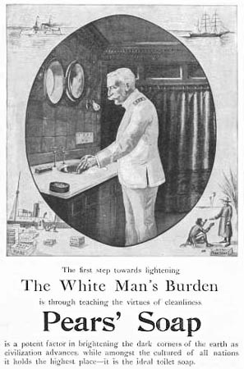
2) Analyse the text underneath the image:
The first step towards lightening
The White Man’s Burden
is through teaching the virtues of cleanliness.
Pears’ Soap is a potent factor in brightening the dark corners of the earth as civilization advances, while amongst the cultured of all nations it holds the highest place- it is the ideal toilet soap.
a) Underline the key words and phrases that refer to the poem
b) How strong is the link between the ad and the poem? Circle your answer
very strong ------ quite strong ------ midway ------- rather weak -------- very weak
c) Lightening has two meanings it could be a pun, the humorous use of a word that has two or more meanings. Find the two meanings of the word and explain the pun.
Meaning 1: __________________________________
Meaning 2 _________________________________
Make statements starting: It could mean ... It could be ...Could it be ....? Etc.
d) Do you think it is likely Pears’ would have intended to make a pun?
very likely ------ quite likely ------ midway ------- unlikely -------- very unlikely
e) Discuss / explain your answers to c) and d) with your partner / the rest of the class.
3) Analyse the main image
a) Describe the main character portrayed and the setting
- Where is he? ___________________________________________________________________________________________________________________________________________________________________________________________________________________________
- What is he wearing? ___________________________________________________________________________________________________________________________________________________________________________________________________________________________
- What is he doing? ___________________________________________________________________________________________________________________________________________________________________________________________________________________________

- What impression does he make on you, his facial expression, his position? ___________________________________________________________________________________________________________________________________________________________________________________________________________________________
- He is .... choose adjectives from the following:
Calm, controlled, authoritative, threatening, dependable, untrustworthy, slovenly, military, reliable, reassuring, frightening, afraid, self-assured, angry, agitated, dirty, untidy, satisfied, irritated, competent, inefficient , happy

- Is he realistic? A stereotype? ___________________________________________________________________________________________________________________________________________________________________________________________________________________________
- Do you know his name? ___________________________________________________________________________________________________________________________________________________________________________________________________________________________
- Do any of the objects which appear in the main picture have any particular symbolic meaning or do they just tell us where he is? ___________________________________________________________________________________________________________________________________________________________________________________________________________________________
- Does the setting itself have a symbolic meaning/association? ___________________________________________________________________________________________________________________________________________________________________________________________________________________________
4) Analyse the frame around the main image
There is a small image in each corner, describe each one:
a) top left: __________________________________________________________
b) top right: _________________________________________________________
c) bottom left: _______________________________________________________
d) bottom right: ______________________________________________________
e) What activity/activities do you associate these images with? _________________
_________________________________________________________________
5) What sort of market, what sort of person do you think Pears’ was trying to reach and sell their product to? Give reasons for your choice.

a) Working classes?
b) Middle classes?
c) Upper classes?
d) Everyone / Anyone?
e) Colonists in particular?
f) Other:

6) What does this tell you about popular opinion regarding Imperialism in the early 1900s? Was it seen as necessary? As good? Or bad? Or some of each? Did people just accept and not ask too many questions about what was going on? Did most people agree with Kipling’s view? Explain your ideas. And discuss them in class.
7) Compare the message and point of view of the advertisement “The White Man’s Burden” with that of the cartoon “The Occupation of Egypt”.

The Occupation of Egypt |  | The White Man’s Burden
message | point of view | message | point of view

ADVERTISEMENT 2 - CAPTION: The Formula of British Conquest
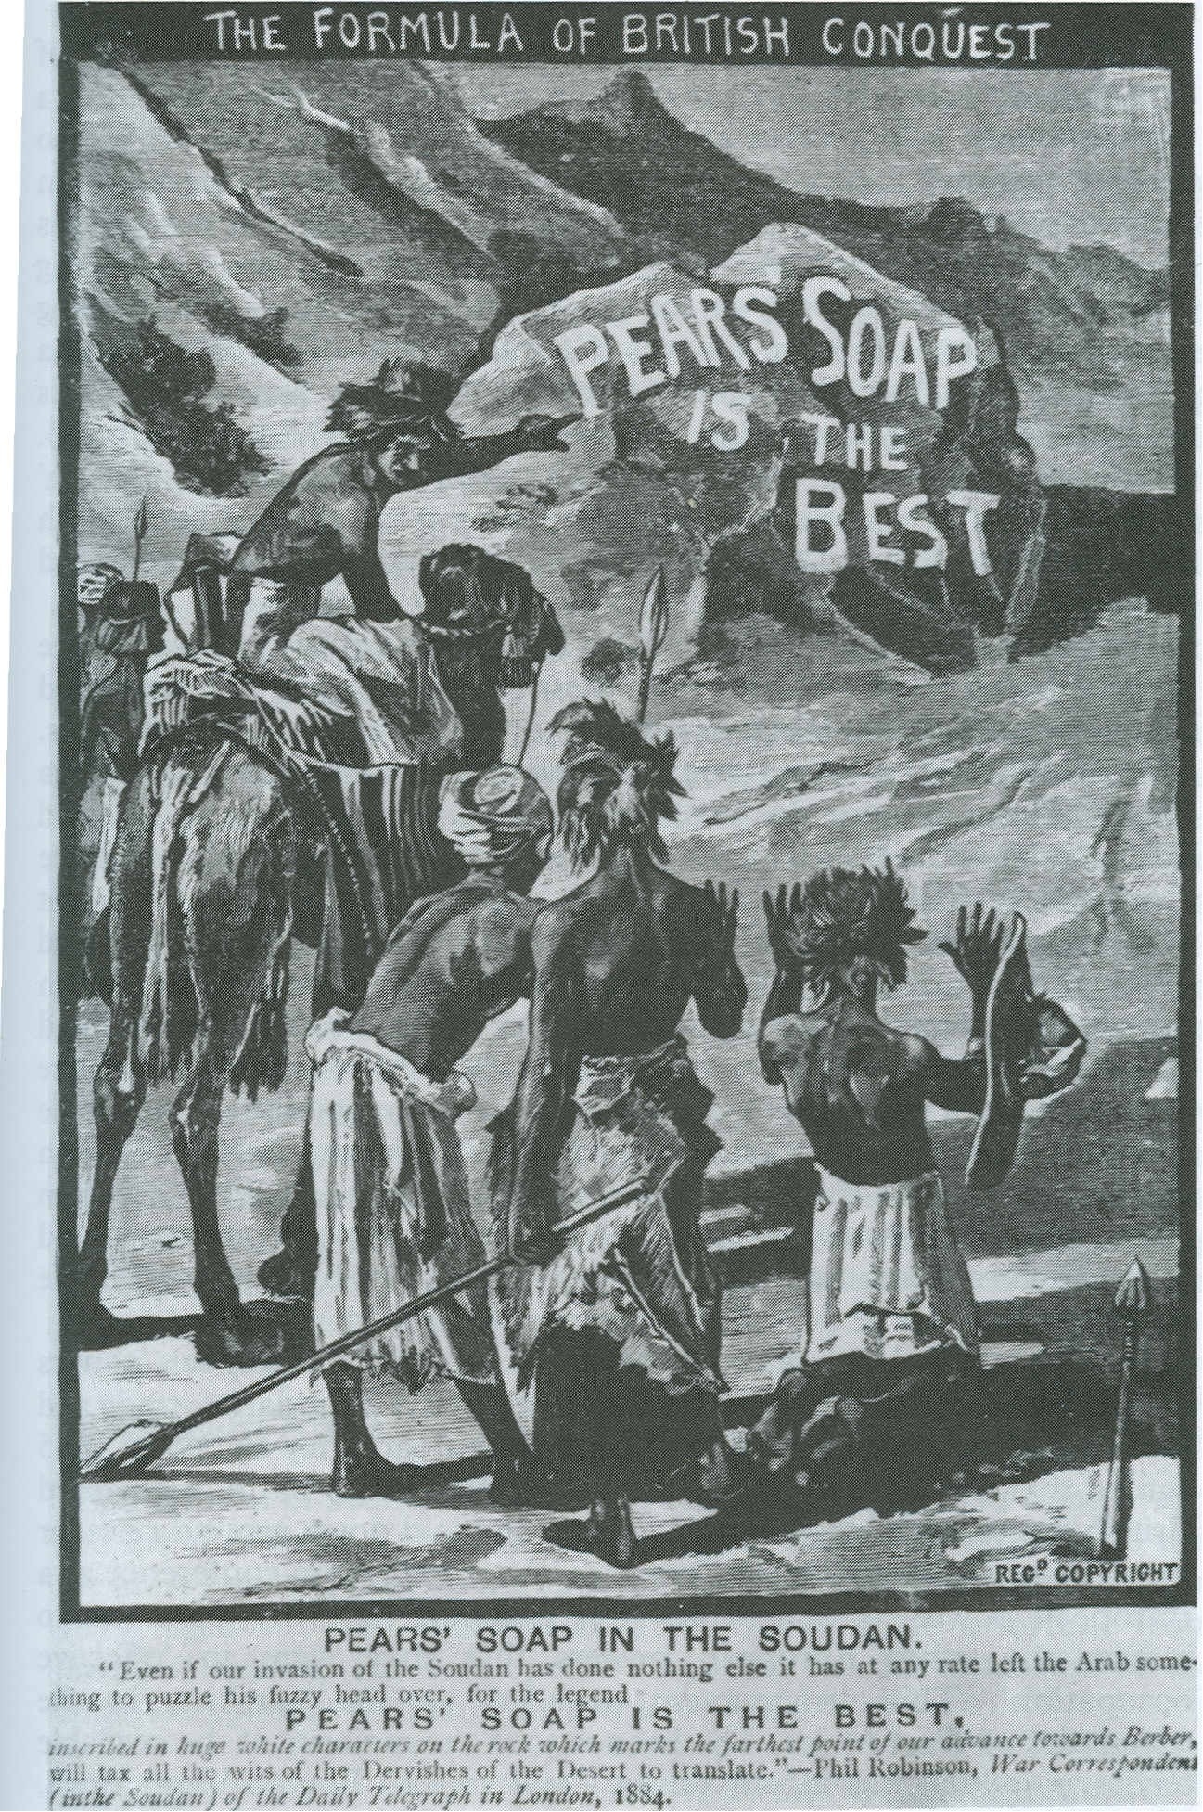
1) Set the scene. Before analysing the cartoon find out about the British Occupation of the Soudan (Sudan) and about Gordon of Khartoum who died in 1884, the year the cartoon was published. Pool your information in class and describe / discuss what was happening in that area at that time.
2) Analyse the Text(s):
a) What is the title?
__________________________________________________________________________________________________________________________________________________________________________________________________________________________________________
b) Why did the cartoonist choose that title? __________________________________________________________________________________________________________________________________________________________________________________________________________________________________________
c) What is it referring to? __________________________________________________________________________________________________________________________________________________________________________________________________________________________________________
d) Read the text below the cartoon:
PEARS’ SOAP IN THE SOUDAN
“Even if our invasion of Soudan has done nothing else it has at any rate (1) left the Arab something to puzzle his fuzzy head over (2), for the legend
PEARS’ SOAP IS THE BEST
inscribed in huge white characters on the rock which marks the farthest point of our advance towards Berber, will tax (3) the wits (4) of the Dervishes of the Desert to translate.” – Phil Robinson, War Correspondent (in the Soudan) of the Daily Telegraph in London, 1884.
(1) at any rate = in any case
(2) to puzzle his fuzzy head over= to think about
(3) to tax = put under strain
(4) wits = intelligence
e) When was the cartoon published? ______________________________________________________________________

f) What was the journalist (Phil Robinson) referring to when he wrote: “Even if our invasion of Soudan has done nothing else it has left the Arab something to think about?” Why “done nothing else? (What happened in 1884?)
__________________________________________________________________________________________________________________________________________________________________________________________________________________________________________

g) Look at what the journalist says about the Sudanese and discuss his comments with a partner, make notes. What do you think his attitude was towards both natives and the Empire? You can use these questions to help you start:
- What is he implying when he says “it will tax the wits of...... to translate?”
- What does he call them; does he describe them at all?
- Is he complimentary?
- What is a Dervish?
3. Describe the image and comment on it:
a) Are there any words in the image itself? __________________________________________________________________________________________________________________________________________________________________________________________________________________________________________
b) How and where are they written? __________________________________________________________________________________________________________________________________________________________________________________________________________________________________________
c) What does the choice of graffiti suggest? __________________________________________________________________________________________________________________________________________________________________________________________________________________________________________
d) What about the natives? How are they standing? What are they doing? Describe them. __________________________________________________________________________________________________________________________________________________________________________________________________________________________________________
e) How would you say they have been portrayed? __________________________________________________________________________________________________________________________________________________________________________________________________________________________________________
4. What message do the image and caption together give? __________________________________________________________________________________________________________________________________________________________________________________________________________________________________________

5. What do you think the cartoonist feels about Imperialism? What is his point of view?
(Note: The Daily Telegraph which he quotes from was/is considered a fairly Conservative newspaper).
__________________________________________________________________________________________________________________________________________________________________________________________________________________________________________
6. In your opinion, which particular aspect of cultural imperialism does the cartoon illustrate and reinforce? Why?
__________________________________________________________________________________________________________________________________________________________________________________________________________________________________________

CARTOON 3 - The Crisis of Empire 1895-1914 The Boer War
CAPTION: HAIL KITCHENER! VICTOR AND PEACEMAKER!
Lord Kitchener returns victorious from the Boer War as 'Victor and Peacemaker'.

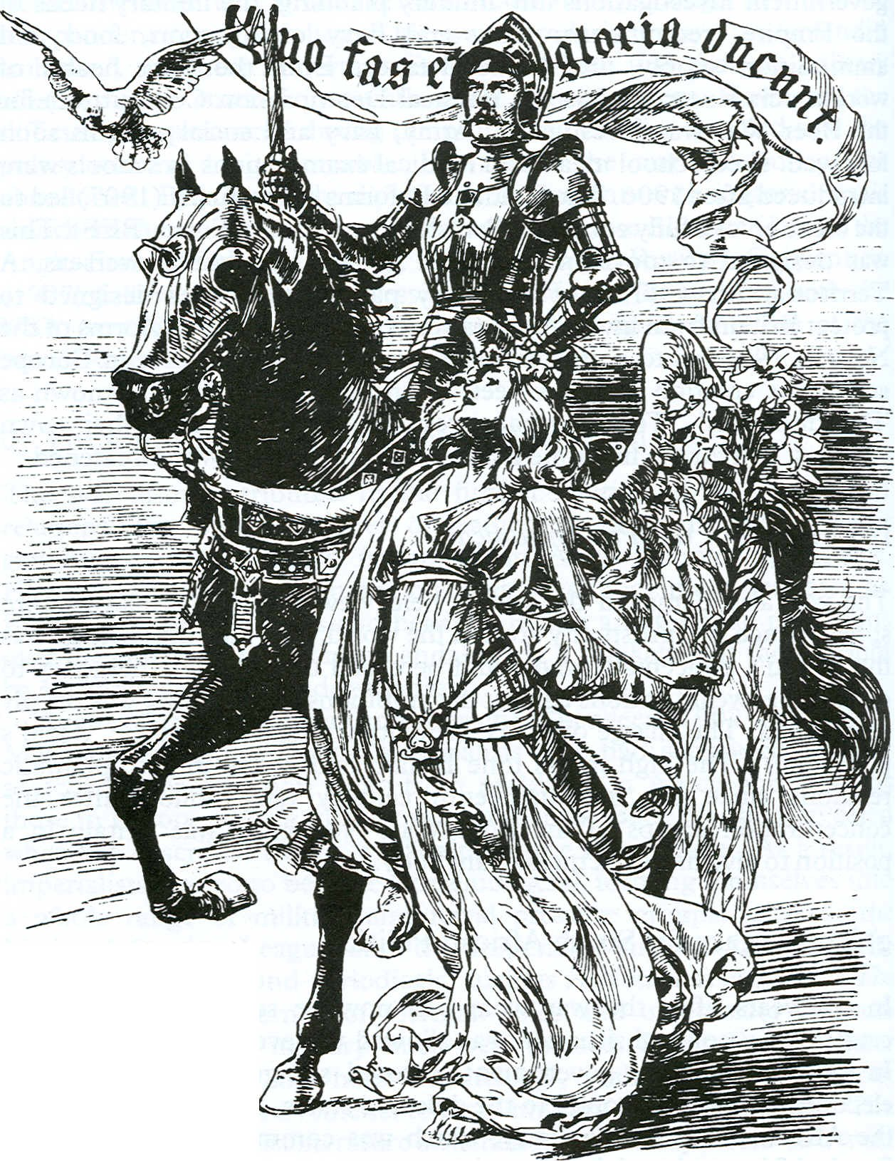
This cartoon was published in Punch, on 9th of July 1902. Punch was a British weekly magazine of humour and satire that was published continuously from 1841 to 1992 and then again, briefly, from 1996 to 2002. It appealed to an educated, thinking, mainly middle-class readership.
1) Set the context of the cartoon by finding out about the Boer War(s) especially in the year the cartoon was published, what do you think the cartoon is about victory or defeat? Who was Lord Kitchener? Share your information with the rest of the class.
2) Analyse the cartoon with a partner by answering the questions in the chart below.

When and where was the cartoon published? | ______________________________________________  ______________________________________________  ______________________________________________  ______________________________________________
Are there any words or text in the cartoon? If yes, where? | ______________________________________________  ______________________________________________  ______________________________________________  ______________________________________________
Describe the people | MAN | WOMAN
How are they dressed?  How are they feeling? (describe their position facial expression)  Who or what do you think they represent?  What are they doing?  Can you identify them by name? (if so, who?)  Are they realistic? Are they stereotypes?  What sort of relationship do they seem to have? | ______________________  ______________________  ______________________  ______________________  ______________________  ______________________  ______________________  ______________________  ______________________  ______________________  ______________________  ______________________ | ______________________  ______________________  ______________________  ______________________  ______________________  ______________________  ______________________  ______________________  ______________________  ______________________  ______________________  ______________________
What about the horse? What is it like? | ______________________________________________  ______________________________________________  ______________________________________________  ______________________________________________
Where is the action set (taking place)? | ______________________________________________  ______________________________________________  ______________________________________________  ______________________________________________
Describe the objects in the cartoon. | ______________________________________________  ______________________________________________  ______________________________________________  ______________________________________________
Do these objects or anything else have any symbolic meanings for you? If so, what do you associate them with? | ______________________________________________  ______________________________________________  ______________________________________________  ______________________________________________
Which particular aspect(s) myths of cultural imperialism is the cartoonist commenting on, criticising, or does he do both? | ______________________________________________  ______________________________________________  ______________________________________________  ______________________________________________  ______________________________________________  ______________________________________________
Summarise the message you think the cartoonist wanted to give the reader, what he wanted to tell people. | ______________________________________________  ______________________________________________  ______________________________________________  ______________________________________________  ______________________________________________  ______________________________________________
Examine the cartoonist’s point of view. In your opinion was he critical of, or praising, Kitchener’s action. Remember where the cartoon was published | ______________________________________________  ______________________________________________  ______________________________________________  ______________________________________________  ______________________________________________  ______________________________________________  ______________________________________________
3) Class Discussion: “A picture is worth a thousand words” is a common saying. Is it true? Are images more effective, better than words, at transmitting messages? Sometimes? All the time? When? Why? Why not?

